|  |
| --- |
| Restaurant Ordering System |
| **Restaurant 362** |
| Software Requirement Specification |

|  |
| --- |
| Matthew Amora, Edgar Cardenas, Lawrence Cui, Manvir Dhillon, & Windly Nguyen  Summer 2024 |

Table of Contents

1. **Introduction**2  
   1.1 Purpose2
   1. Scope2

1.3 Definitions3

1.4 References4

1. **Overall Description**4

2.1 Product Perspectives4

2.1.1 User Interface4

2.1.2 Software Interface5

2.2 Product Functions5

2.3 User Characteristics5

2.4 General Constraints6

2.5 Assumptions and Dependencies6

1. **Specific Requirements**6

3.1 Functional Requirements6

3.1.1 Use Case Diagram8

3.2 Non-functional Requirements8

3.3 Data Requirements8

3.4 Design Constraints9

**1. Introduction**

1.1 Purpose

This SRS (Software Requirements Specification) document aims to define the specific software needs and requirements for “Restaurant 362’s” pick-up ordering system. This system offers customers a platform to browse and customize items, place orders, access order history, and save favorite items from the restaurant’s menu. The outlined requirements must be met and tested by the end of our CPSC 362 Software Engineering course in the Summer of 2024.

1.2 Scope

Refer to the Use Case diagram in Section 3.1.1 on page 7.

The “Restaurant 362” web-based application optimizes and manages pick-up orders for its ++customers. Customers with and without an account can place orders via a user-friendly interface, facilitating menu browsing, order customization, and communication with restaurant staff for special requests. The system will send an automated email with an order confirmation and time estimate. Customers with an account benefit from additional features such as viewing order history and saving favorited orders.

1. User Access
   1. Home Page
      1. Users are greeted by visuals of Restaurant 362’s menu items and interactive components to streamline the ordering process. Customers can quickly initiate pick-up orders, view the menu, and access information such as the restaurant’s location, order history, and account details.
   2. Navigation bar
      1. Menu
         1. The Menu section is a single web page displaying Restaurant 362’s food items. Customers can explore a selection of available items across multiple categories. Once orders are made, an email confirmation of the order status will be sent.
      2. Location
         1. Customers can discover the nearest restaurant location by entering their current address. The system will integrate mapping technologies to display the calculated distance and time to the nearest Restaurant 362.
      3. Orders
         1. Favorited Orders
            1. An account holder will be presented with their saved orders at the top of the Orders webpage. Customers can easily reorder their favorite orders without browsing the menu and customizing their order.
         2. Order History
            1. A detailed list of all past orders placed by account holders will follow the Favorited Orders section. Each entry is a comprehensive summary of each order, including date, time, total price, and order status.
         3. Guest User Access
            1. If a guest user has not placed an order at Restaurant 362, they will be presented with an interactive button paired with the text, “Save and view your order history by creating an account with us!”
            2. If a guest user placed an order, the user can view details of their current order, including menu items selected, special requests, and total price.
      4. Login and Account Management
         1. Account Creation
            1. Users can create accounts by providing a valid email address and entering a secure password.
         2. Account Settings
            1. Account holders can update their account settings, such as username, password, email address, and phone number.

1.3 Definitions

1. Application
   * A Program or a piece of software developed specifically to aid a user performing any specific task.
2. Back End
   * The part of the application that provides most of the functionality, but the user never directly interacts with.
3. Cascading Style Sheets (CSS)
   * Web technology written in markup languages like HTML to stylize elements of a document.
4. Front End
   * The part of a computer application that the user directly interacts with.
5. GitHub
   * A software platform for developers to create, discuss, manage, and store shared or unshared code.
6. Graphical User Interface (GUI)
   * A visual way of interacting with a computer using items such as windows, icons, and menus, used by the most modern operating systems.
7. Hashing
   * Taking an input and returning a fixed-size string of bytes.
8. Hypertext Markup Language (HTML)
   * A standard web technology language describing the structure and layout of a web page or website.
9. Integrated Development Environment (IDE)
   * A software that helps programmers develop software code efficiently.
10. JavaScript (JS)
    * A high-level programming language widely used in front-end development.
11. Minimum Viable Product (MVP)
    * A complete and usable product with the bare minimum features required.
12. Operating Software (OS)
    * A system software that manages computer hardware and software resources and provides common services for computer programs.
13. Program
    * A detailed plan or procedure for solving a problem with a computer; more specifically, an unambiguous, ordered sequence of computational instructions necessary to achieve such a solution.
14. Python
    * A high-level programming language, that supports object-oriented programming, used widely in back-end development.
15. Salted
    * A random piece of data used as an additional input to the hash function.
16. Software
    * The programs and other operating information used by a computer.
17. Unified Modeling Language (UML) Diagram
    * It is a general-purpose modeling language. Defines a standard way to visualize the way a system has been designed.
18. User (Customer)
    * A person that uses or has access to a program or web application.
19. User Interface (UI)
    * The part of the application that the user interacts with. The point of human-computer interaction and communication in a device.
20. Web Browser
    * An online software that allows users to access websites or web applications if the user has access to the internet.

1.4 References

* *Dickey’s Barbecue Pit*. Dickey’s Barbecue Pit - BBQ Near Me | Food Near Me | Lunch Restaurants. (n.d.). https://www.dickeys.com/

**2. Overall Description**

2.1 Product perspectives

2.1.1 User Interface

**Without an Account (Guest):**

* When the user is not signed in with an account, they are treated as a guest and they will still have access to everything on the website, including browsing the menu, placing an order, and viewing the restaurant's location.
* If the user does not have an account, they can create an account through the sign-up link on the top right of the webpage. This will then bring them to a new web page where they can create an account with a username and password.
* If the user wishes to sign in to their account, they can also do so through the sign-in link on the top right of the page with a valid username and password.

**With an Account (Account Holder):**

* When the user is signed in, they have an identical view as to that of someone who is signed out/guest. The main difference is that the user's name will be displayed near the top of the page and their favorite items will be displayed.
* The user would also be able to view their past orders and favorite foods. Their payment method and information will also be saved and will be secure in our database.

2.1.2 Software Interface

* For our front-end development of our Restaurant System website, we will be using HTML, CSS, and JavaScript (JS). These technologies will handle the structure, design, and interactivity of our user interface (UI). For our website, HTML will create the structure and layout, CSS will be used to style our UI, and JavaScript will allow our website to be interactive.
* For our back end, we will be using Python, and or to handle data processing through accessing a .txt file with all relevant information.

2.2 Product Functions

* Users will be able to browse the restaurant’s complete menu online, including detailed descriptions, prices, and images of each dish.
* Users can place orders directly through the website, selecting items from the menu and adding them to their virtual cart. The order process will include the pickup time and location of the restaurant.
* Users with accounts can manage their profiles, including updating personal information, viewing order history, and saving favorite items for quick access on future orders.
* The email confirmation will provide the order details and the estimated time required to finish the order.

2.3 User Characteristics

Users will be able to perform the following functions:

1. Guest Features:
   1. Remain logged out and use guest features, including browsing the menu, placing orders, and viewing restaurant locations without the need for an account.
2. Account Creation and Login:
   1. Input valid credentials (username and password) to create an account, enabling personalized features and a more streamlined experience.
   2. Sign in to their account using valid credentials to access personalized features and stored information.
3. Order History:
   1. View previous orders while signed-in.
   2. Mark items on the menu as favorites and view all favorited items.
4. Account Management:
   1. Update their personal information
   2. Have the option to delete their account
   3. Change existing information on account (username and password)
   4. Update or save payment information for faster checkout.
5. Website Interaction:
   1. Browse the website seamlessly and experience a user-friendly user interface for easy navigation and usage.

2.4 General Constraints

* Time Constraints: The project timeline spans a short semester, necessitating prioritization of features due to potential constraints on implementation within the allotted period. We will focus on delivering a minimum viable product (MVP) before the deadline.
* Scheduling: Each team member's unique schedule, including other classes and jobs, poses challenges in coordinating meetings, thereby affecting our productivity.
* Technical Constraints: The team’s varying levels of knowledge of the chosen languages (HTML, CSS, JavaScript, Python, SQL) may affect speed and quality of development.
* Experience Level: The team members are all new to full-stack development and somewhat new at working collaboratively in a team environment. This learning curve may impact the project timeline and deliverables.

2.5 Assumptions and Dependencies

* Users are familiar with basic internet browsing and navigation skills.
* Users will primarily access the website from the desktop rather than mobile devices.
* Users have a stable internet connection on their devices to access the website without interruptions.
* Users can read and understand the English language to navigate the website
* Users possess valid payment methods for completing online transactions.
* Website functions correctly on major web browsers like Google Chrome, Mozilla Firefox, and Safari.
* Users are expected to pay in US dollar for each menu item.

**3. Specific Requirements**

3.1 Functional Requirements

1. Account Functions
   1. Logout of Account
      1. The user will be able to log out of their account.
   2. Retrieve Order History
      1. The user will be able to review details about their order history.
   3. Save Favorites
      1. The user will be able to save menu items as “favorites.”
      2. The user will be able to remove their favorite items.
   4. Remove Favorites
      1. The user will be able to unmark items as favorites.
   5. Create Account
      1. The user will be able to create an account by entering a valid email address.
   6. Login to Account
      1. The user can log in through the sign-in link at the top of the webpage and input their valid username and password.
2. Account Management
   1. Change User Information
3. The user will be able to reset their password.
4. The user will be able to save a payment method.
5. The user will be able to change their saved address and phone number.
6. The user will be able to delete their account.
7. Order Error
   1. Report Invalid Payment Method
      1. The system will send an error message if the user inputs an invalid payment method.
8. Order Management
   1. Place Order
      1. The user will place an order for pick up by adding items to their order, which they can customize and leave notes on.
   2. Make Payment
      1. The user will input their payment method (credit card) to complete their order.
   3. Create Order Confirmation
      1. The system will create an order confirmation with the total price, items, and instructions and send it in an email to the user.
      2. The system will generate a link to the order status which will then be provided with the order confirmation email.
   4. Retrieve Order
      1. The user will be able to view the status of their order though the website with a link provided in their order confirmation.
   5. Customize Order
      1. The user will be able to customize food items to their preference by using check boxes next to ingredients listed in the item description when ordering an item.
      2. The user can provide instructions in a text box provided in the item description when ordering an item.
   6. Cancel Order
      1. The user can cancel submitted orders if the request is placed within a 2-minute grace period.
9. Restaurant management
   1. Retrieve Menu
      1. The user can view an online version of the restaurant menu, which will describe the item and the price for an unmodified item.
   2. Retrieve Restaurant Location
      1. The user will have access to a link to the restaurant's location on Google Maps.

3.1.1 Use Case Diagram

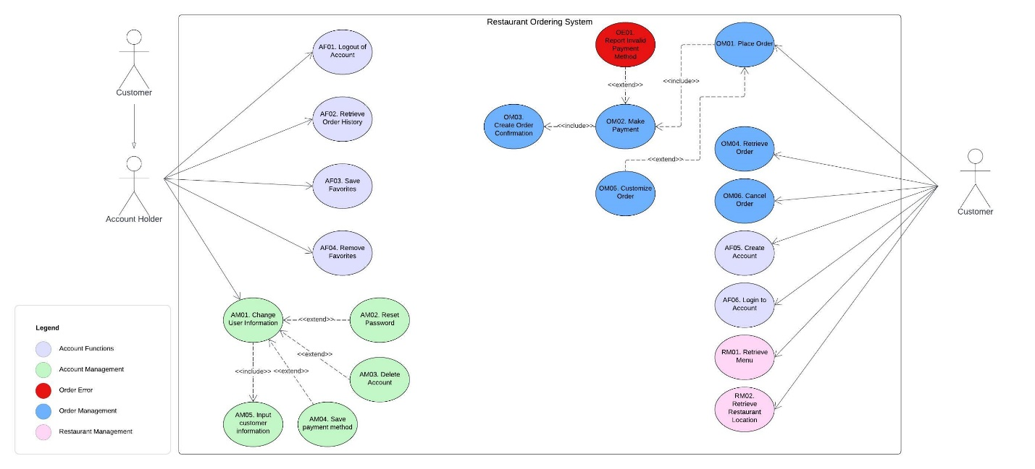

3.2 Non-functional Requirements

* Accessibility
  + The system should be compatible with commonly used web browsers, ensuring equal accessibility and functionality across different platforms.
* Efficiency
  + System should process user requests within 3 seconds to ensure responsive and efficient performance.
* Performance
  + Optimize page load times to ensure that content loads quickly, especially for users with limited bandwidth or older devices.
* Reliability
  + System should ensure uninterrupted availability and operation, maintaining continuous uptime and preventing any downtime.
* Security
  + System should implement protocols to ensure data confidentiality and integrity during transmission and storage.
* Usability
  + The system should be easy to use and user-friendly, accommodating users with a wider computer experience.

3.3 Data Requirements

* User Data (Account Holder)
  1. User ID
  2. Name
  3. Email
  4. Password (hashed and salted)
  5. Contact Number
* Order Data
  1. Order ID
  2. User ID
  3. Menu Item ID
  4. Quantity of Each
  5. Total Price
  6. Order Status
  7. Time of Order

3.4 Design Constraints

* Users are expected to have internet access and a web browser to use the application.
* Users are expected to have a valid payment method available to place an order.
* The web application’s interface is not compatible with mobile devices.